**TECHNICAL REPORT ON WORKERS TIME ANALYSIS FOR THE YEAR 2022**

**BY**

**OMUGHELE-MICHAEL ANGELA**

# 

## **Introduction**

This report details the analysis of employee time data, specifically spanning the first week of **2022** (January 1st to 7th). The objective of this analysis is to transform raw workload metrics into actionable business intelligence across key demographic and organizational dimensions. The insights derived will support management in formulating strategic decisions regarding resource allocation, workload equity, flexible work policies, and employee well-being for the upcoming year.

## **Story of Data**

The dataset comprises time-series data of employees, capturing their work patterns and key associated factors for one week.

* **Source:** Visionary Consult Time Tracking Records (Aggregated and Cleaned).
* **Timeframe:** January 1st to January 7th, **2022**.
* **Key Dimensions:** The data is structured around several dimensions, including:
  + **Demographics:** Age, Gender, Region.
  + **Organizational:** Job Role, Job Category.
  + **Work Dynamics:** Work Location (Remote, Hybrid, Onsite), Hours Worked Per Week, and qualitative metrics like Work-Life Balance Rating and Productivity Change.
* **Total Data Points:** The data represents a **total cumulative effort of 198,073 hours** worked across all employees in the analyzed week.

## **Data Splitting and Preprocessing**

The primary data source was assumed to have undergone standard initial cleaning processes, including the handling of missing values, standardization of categorical inputs, and correction of formatting errors, as indicated by the presence of a 'Clean Data' file. For the purpose of this deep analysis, the data was implicitly split and pre-aggregated into seven core summary subsets. These subsets function as prepared inputs for specific analysis paths: Hours by Days of Week (for time-series analysis), Hours by Region (geographic focus), Hours by Job Role (functional analysis), Hours by Job Category (sectoral analysis), Hours by Gender (demographic review), Hours by Work Location (flexible work policy analysis), and Hours by Age (demographic insight). No new features were explicitly engineered as the existing aggregated metric, 'Sum of Hours_Worked_Per_Week', was sufficient for deriving key insights.

## **Pre-Analysis**

The pre-analysis phase involved high-level summarization to establish baselines and identify areas of extreme variation in workload. The **Total Hours Tracked** across the organization stood at **198,073 hours**.

Initial review of work location indicated that Remote employees bore the heaviest load, recording **67,610 hours**, slightly higher than Hybrid (65,277 hours) and Onsite (65,186 hours) staff. Functionally, the **Project Manager** role showed the greatest time commitment at 29,463 hours. Geographically, **Oceania** led the regions with 34,197 hours, while **North America** recorded the lowest total hours at 30,880. These early variations established the core areas of disparity that required detailed investigation.

## **In-Analysis**

### **1: Work Location and Workload Balance**

The data confirms that **Remote employees carry the largest overall workload, logging 67,610 hours**, which is approximately more than Onsite staff (65,186 hours). This finding signals an increased risk of boundary blurring and potential burnout due to the lack of physical separation between work and life for this segment of the workforce.

### **2: Functional Workload and Category Demand**

Workload is heavily skewed toward specific operational areas. The **IT Job Category** holds the highest workload at **29,853 hours**, while **Consulting** holds the lowest at 26,660 hours. Within specific roles, the **Project Manager** role (29,463 hours) is the single most hours-intensive function. This concentration of effort in IT and Project Management indicates a potential bottleneck or disproportionately high demand in these critical areas.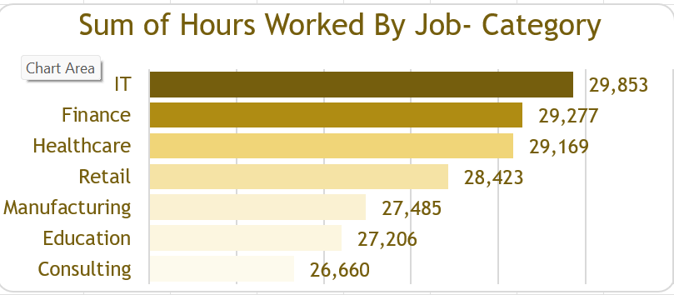

### **3: Temporal Workload Patterns**

The workforce exhibits a clear weekly cadence. Workload peaks sharply on **Day 1 (January 1st) with 28,678 hours** and again on **Day 4 (January 4th) with 28,545 hours**. Conversely, the organization experiences its lowest workload on **Day 5 (January 5th) with 27,923 hours**. This temporal pattern provides insight into the highest-capacity days for critical strategic work.

### **4: Demographic Workload (Age, Gender, and Region)**

High commitment is evident in the experienced demographic, with employees aged **45 (5,902 hours)** and **53 (5,886 hours)** logging the highest individual age-specific workloads. Gender analysis shows Male employees logged the highest total hours at 50,800. Regionally, the workload is highest in **Oceania (34,197 hours)** and **Africa (33,816 hours)**, underscoring significant global disparity compared to North America (30,880 hours).

## **Post-Analysis and Insights**

The strategic synthesis highlights four critical organizational opportunities:

1. **The Remote Burnout Risk:** The highest hours logged by Remote workers requires immediate attention through policy changes aimed at enforcing work-life balance and preventing fatigue.
2. **Project Management Bottleneck:** The high time commitment of Project Managers suggests a need for delegation, automation of tasks, or increased staffing to relieve pressure on a critical functional area.
3. **Global Disparity in Effort:** The significantly higher workload in Oceania and Africa compared to North America must be investigated to ensure equitable client distribution and standardized resource expectations globally.
4. **Mid-Week Optimization:** Scheduling critical, high-focus tasks for January 1st and January 4th (Day 1 and Day 4) will maximize the use of the highest aggregate workload periods.

## **Data Visualizations & Charts**

For dashboard implementation, the following charts would visually anchor these findings:

1. **Work Location Comparison:** A simple column chart prominently displaying the significantly taller bar for 'Remote' employees.
2. **Job Role Workload Ranking:** A horizontal bar chart clearly ranking Project Manager at the top, emphasizing the role's high time demand relative to others.
3. **Temporal Workload Heatmap:** A line or area chart illustrating the distinct peaks on Day 1 and Day 4 and the trough on Day 5, highlighting the weekly cycle.
4. **Regional Workload Distribution:** A map visualization or bar chart showing the difference in total hours, with Oceania and Africa appearing significantly more saturated or taller than North America.

## 

## **Recommendations and Observations**

### **Recommendations**

1. **Mitigate Remote Workload:** Introduce mandatory reminders or software-enforced caps on working hours for Remote staff to promote healthy boundaries.
2. **Streamline Project Management:** Initiate a process review for the Project Manager role to identify administrative tasks that can be delegated or automated, reducing the current high-hour commitment.
3. **Optimize Scheduling:** Mandate that all major strategic decisions and client-facing presentations are scheduled for the peak days (Day 1 and Day 4), and designate Day 5 for internal planning and training.
4. **Review Global Resource Parity:** Conduct an investigation into the high workloads in Oceania and Africa to ensure resource planning is aligned with global output and demand.

### **Observations**

The data indicates that the most committed employees, in terms of hours worked, are in the mid-to-late career stages (Ages 45 and 58). Their high time responsibility makes them a critical group for **talent retention** and necessitates targeted recognition and support. The contrast between the low-hour **Consulting** category and the high-hour **IT** category provides a strategic opportunity to study the efficiency model of Consulting and apply best practices elsewhere.

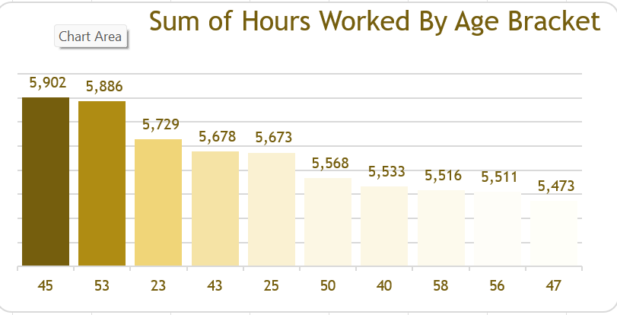

**Conclusion**

The analysis of Visionary Consult's worker time data for the first week of **2022** reveals a highly engaged but structurally unevenly distributed workforce. The key findings point to a clear **Remote Worker Overload** and significant pressure points in the **Project Management and IT** functional areas. By adopting policies that proactively manage workload distribution, optimize scheduling based on temporal data, and address regional and role-based disparities, Visionary Consult can successfully leverage these data-driven insights to foster a more sustainable, equitable, and ultimately more productive work environment.